Vender Performance Analysis Report
Business Problem :
Effective inventory and sales management are critical for optimizing profitability in the retail and wholesale industry. Companies need to ensure that they are not incurring losses due to inefficient pricing, poor inventory turnover or vendor dependency.
The Goal of this analysis is to :
- Identify underperforming brands that require promotion or pricing adjustments.
- Determine Top Vendors contributing to sales and gross profit.
- Analyse the impact to bulk purchasing on unit costs.
- Assess inventory turnover to reduce holding costs and improve efficiency.
- Investigate the profitability variance between high-preforming and low-performing vendors.

Exploratory Data Analysis Insights
Summary Statistics
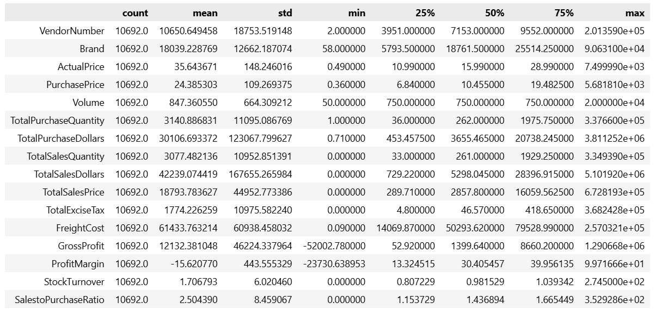
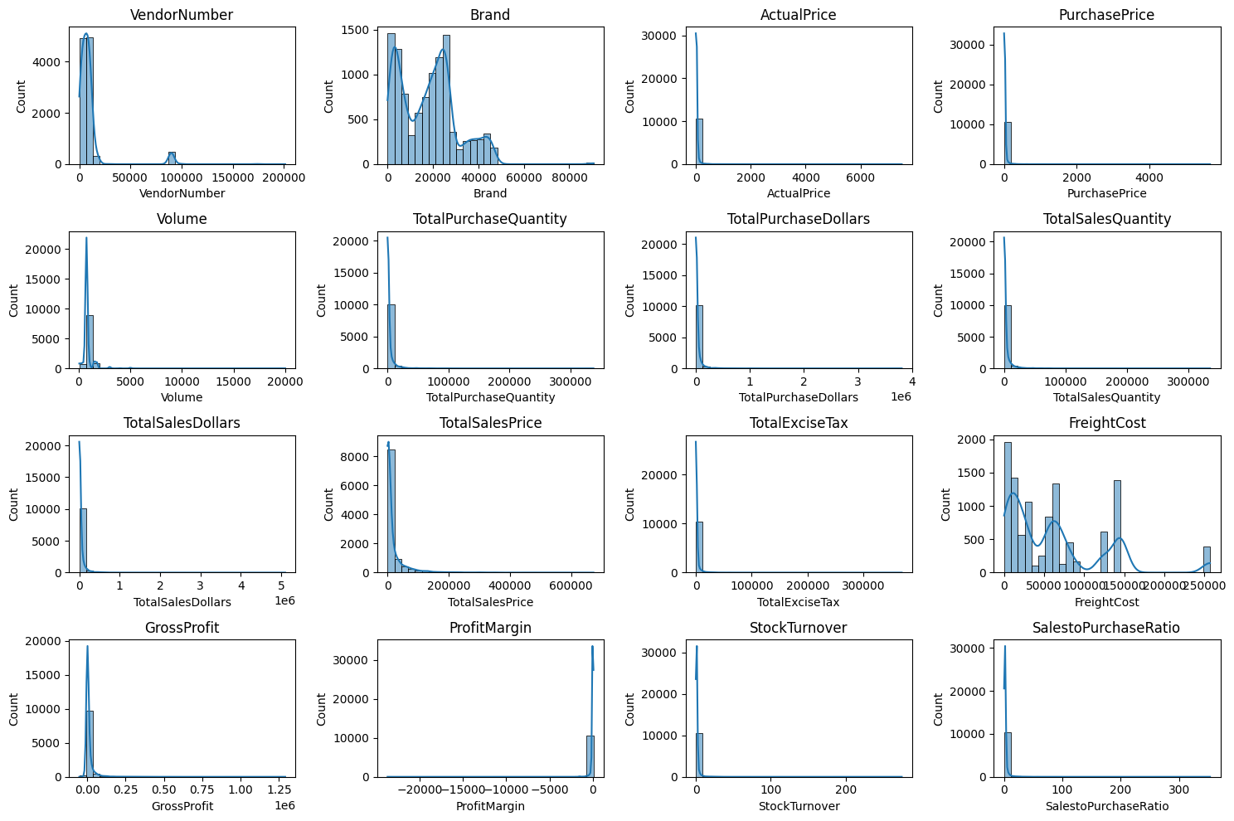
Negative & Zero Values :
Gross Profit : Minimum of -52,002.78 indicating potential losses due to high costs and heavy losses. This could be due to selling products at lower prices than their purchase costs.
Profit Margin : Has minimum of -23,730, which suggests instances where revenue is zero or even lower than the total cost, leading to extreme negative profit margins.
Total Sales Quantity & Sales Dollars : Some product show zero sales, indicating they where purchased but never sold. This may be slow moving or absolete stock, leading to inventory inefficiencies.
Outlier Detected by High Standard Deviations :
Purchase & Actual Prices : The maximum values (5681.81 & 7499.99) are significantly higher than the mean (24.39 & 35.64), indicating premium product offerings.
Fright Cost : Extreme variation from 0.09 to 257,032 suggest logistic inefficiency, bulk shipments or erratic shipping costs across different products.
Stock Turnover : Ranges from 0 to 274, some product sales rapidly while other remain unsold for long periods. A value greater than 1 indicates that sales for a product exceed the purchased quantity due to older stock fulfilling orders.

Data Filtering
To enhance the reliability of the insights, we remove inconsistent data points where :
- Gross Profit <= 0 (to exclude the transaction leading to losses)
- Profit margin <= 0 (to ensure analysis focuses on profitable transactions)
- Total Sales Quantity = 0 (to eliminate inventory that was never sold)

Correlation Insights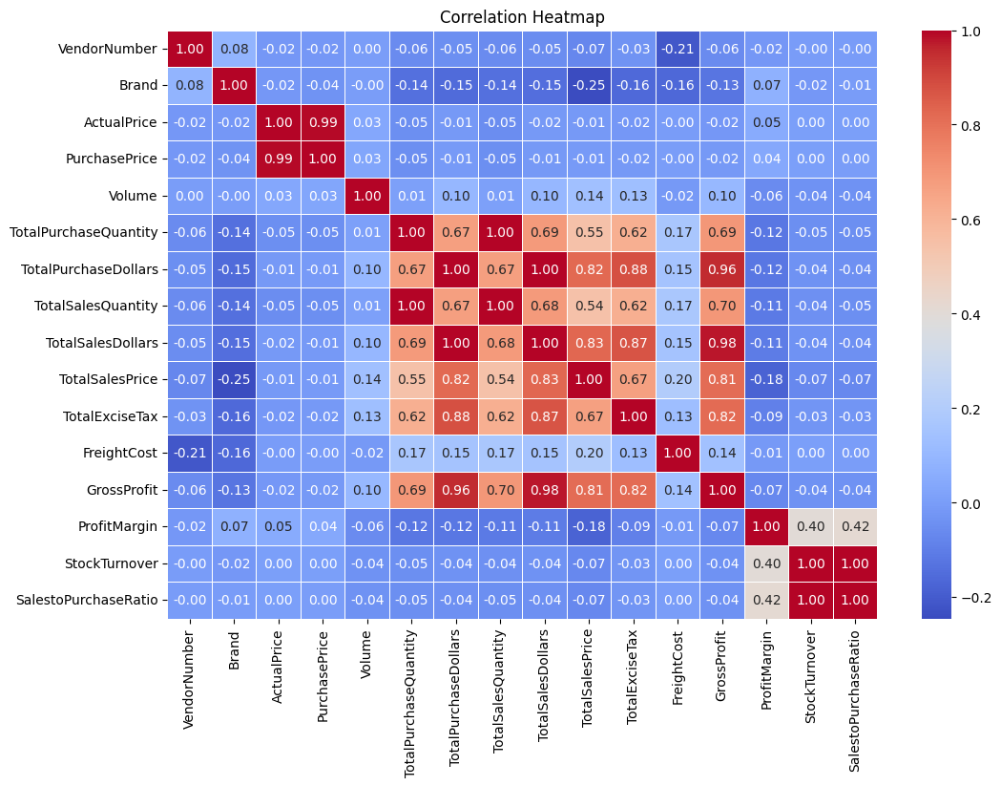
Purchase Price Vs. Total Sales Dollars & Gross Profit : Weak correlation (-0.012 and -0.016) indicating price variations do not significantly impact sales revenue or profit.
Total Purchase Quantity vs Total Sales Quantity : Strong correlation (0.99) confirming efficient inventory turnover.
Profit Margin vs Total Sales Price : Negative correlation (-0.179) suggesting increasing sales prices may lead to reduced margins possibly due to competitive pricing pressures.
Stock Turnover vs Gross Profit & Profit Margin : Weak negative correlation (-0.038 & -0.055) indicating that faster stock turnover does not necessary equate to a higher profitability.

Research Questions & Key Finding
- Brands for Promotional or Pricing Adjustments
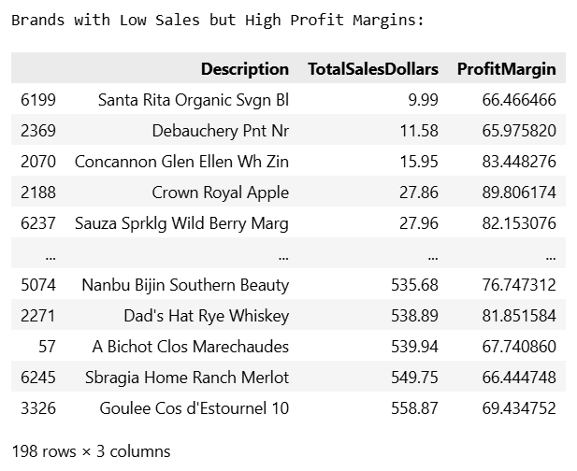
198 brands exhibit lower sales but higher profit margins, which could benefit from targeted marketing, promotion, or price optimizations to increase volume without compromising profitability.
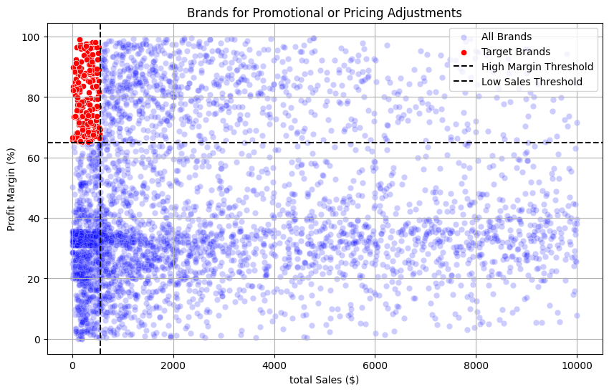

- Top Vendors by Sales & Purchase Contribution
The Top 10 vendors contribute 65.69% of total purchase, while the remaining vendors contribute only 34.31%. This over-reliance on few vendors may introduce risks such as supply chain distributions, indicating a need for diversification.
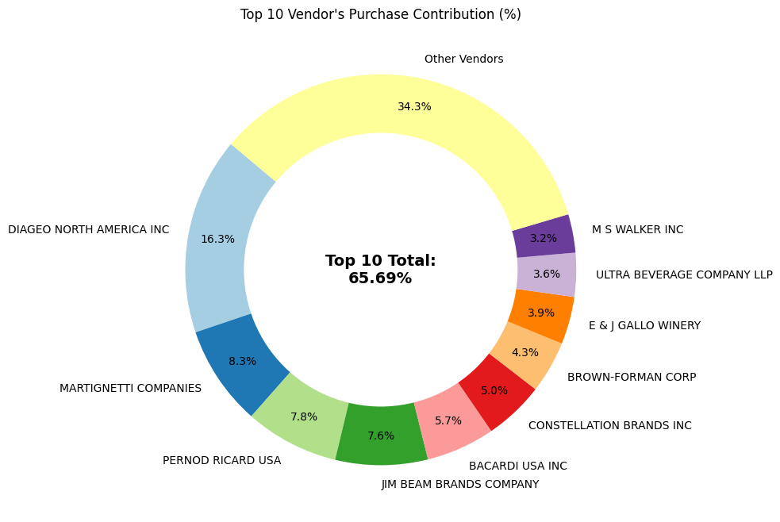
- Impact of Bulk Purchasing on cost saving
Vendors buying in large quantities receive a 72% lower unit cost ($10.78 per unit vs higher unit costs in smaller orders).
Bulk pricing strategies encourages larger orders, increasing total sales while maintaining profitability.
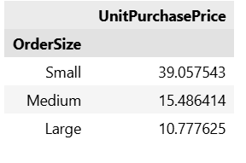

- Identifying Vendors with Low Inventory Turnover
Total Unsold Inventory Capital: $2.71M
Slow moving inventory increases storage costs, reduce cash flow efficiency, and affects overall profitability.
Identifying vendors with lower inventory turnover enable better stock management, minimizing financial strain.
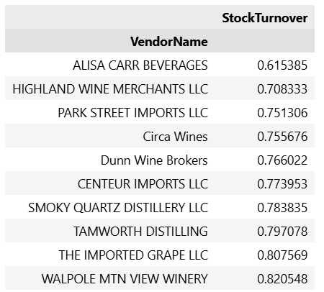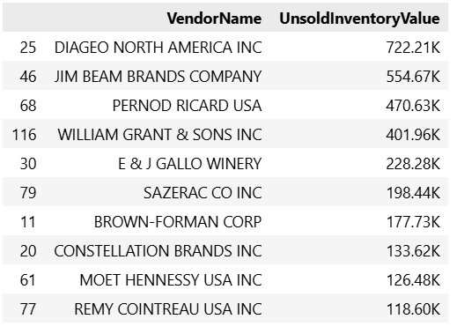

- Profit Margin Comparison : High vs Low-Performing Vendors
Top Vendors - Profit Margin (95% CI): (34.74%, 31.61%), Mean: 31.71%
Low Vendors - Profit Margin (95% CI): (40.48%, 42.62%), Mean: 41.55%
Low performing vendors maintain higher margins but struggle with sales volume indicating potential pricing inefficiencies or market reach issues.

Actionable Insights:
- Top Performing Vendors: Optimize profitability by adjusting pricing, reducing operational costs or offering bundled promotions.
- Low Performing Vendors: Improve marketing efforts, optimizing pricing strategies and enhance distribution networks.
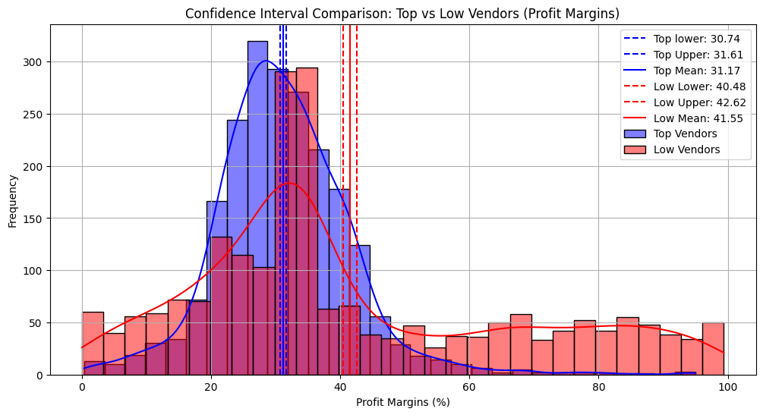
- Statistical Validation of Profit Margin Differences
Hypothesis Testing:
H0 (Null Hypothesis): No significant different in profit margin between top and low performing vendors.
H1 (Alternative Hypothesis): A significant difference exists in profit margin between the two vendor groups.
Result: The Null Hypothesis is rejected, confirming that two group operate under distinctly different profitability models.
Implication: High margin vendors may benefit from better pricing strategies, while top selling vendors could focus on cost efficiency.

Final Recommendations
- Re-evaluate pricing for low sales, High margin brands to boost sales margins without sacrificing profitability.
- Diversify vendor partnership to reduce dependency on a few suppliers and mitigate supply chain risks.
- Laverage bulk purchasing advantages to maintain competitive pricing while optimizing inventory management.
- Optimize slow moving inventory by adjusting purchase quantities, launching clearance sales or revising storage strategies.
- Enhance marketing and distribution strategies for low performing to drive high sales volumes without compromise profit margin.
- By Implementing these recommendations, company can achieve sustainability, profitability, mitigate risk and enhance overall operational efficiency.

